Behavior and Activity Mapping of Decatur, GA

Meryl Pawlick, Thomas Pharr, Harrison Siegel

Intro to Land Use

CP 61132

November 2, 2025

1. **Overview**

We will be assessing the quality of the City of Decatur’s land use by analyzing the behavior of three interconnected dimensions of activity: traffic, pedestrian/cyclist, and street design. Street design significantly affects the flow of traffic and consequently the walkability and bike ability of an area. Auto-centric design versus pedestrian-centric design speaks to the degree of Decatur's success with their intended land use and how effective the zoning and aspirational designations have been.

We conducted two site visits to gain a more thorough understanding of Decatur’s pedestrian/cyclist and car activity. Our first site visit was on a Thursday from roughly 5:30-8:30 p.m. We picked this time to observe rush hour traffic, individuals dining downtown, and potential foot traffic as people walk dogs or engage in exercise in the evenings after work. In this time frame we were able to observe how activity changed as the sun set. The conditions for this visit were cold, windy, and overcast.

Our second site visit was on a Sunday morning from 10:30 a.m.-1 p.m. We observed general weekend activity and reflected on the potential influence that Sunday morning church may have had on observed patterns of behavior. The conditions on this day were sunny and warm. We understand that the discrepancies in our data, specifically in regard to pedestrian/cyclist activity between our observations, are likely attributed to the impact of weather. In our analysis, we have included data on traffic from both site visits, as we believe the weather minimally impacted traffic use, and have primarily represented the data from our second site visit for pedestrian activity as the trends we witnessed were consistent but exaggerated on the weekend when the weather was pleasant.

Our methodology for each metric is based on a Likert scale of *low*, *medium*, and *high* activity. Each definition of these metrics is based on the measure variable. For example, the *low* measurement for traffic volume is anything less than 15 cars at a given intersection. This is the general theme for numeric indicators via all data collected, and each scale is specified within the respective sections that follow. What was not explicitly numeric was our observations from site visits. An example can be the actual speed we observed compared to the posted speed limits. We detail all our data and our points of interest (POIs) in an accessible spreadsheet [here](https://gtvault-my.sharepoint.com/personal/tpharr3_gatech_edu/_layouts/15/Doc.aspx?sourcedoc=%7B2BE4E61D-BFEE-4BAD-9E95-D08374A427B4%7D&file=Data%20Deliverable%202.xlsx&action=default&mobileredirect=true). Our maps and findings are drawn from this data.

1. **Traffic Analysis**

The traffic in Decatur varies through the regions we explored. Through our analysis we examined select intersections via our site visits, ranging from downtown Decatur to the northern limits of the city. Below is the final map of our site visits, described as low, medium, and high traffic volumes at each intersection. Our definition for *low* traffic count is less than 15 cars at the given intersection. *Medium* is defined as between 15-25 cars at the intersection. Lastly, *high* is defined as greater than 25 cars at the given intersection. The data shows a heavy car centric system through downtown and the western observed intersections. The neighborhoods north of downtown saw less traffic and overall were more pedestrian friendly.

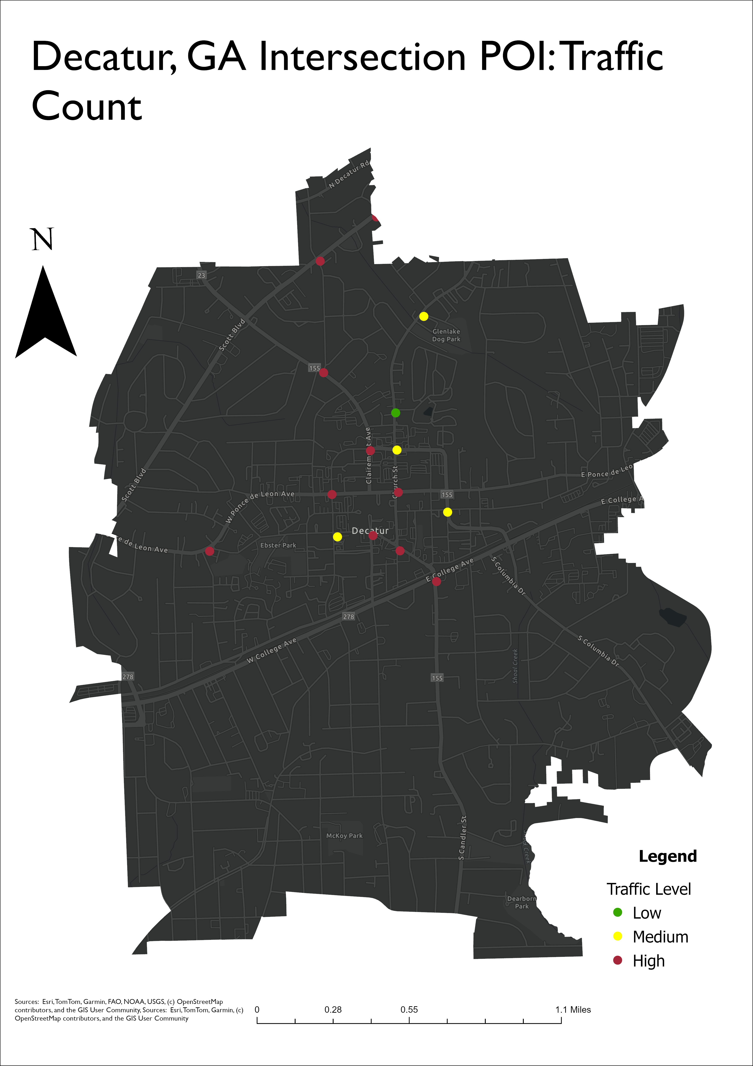

The intersection that had the most observed traffic was Commerce Dr. & Clairemont Ave. This intersection has two lanes, westbound and eastbound via Commerce Dr., each with a left turn lane. Each direction also has two lanes, one for through traffic and one for through/right turn traffic. These lanes also feature a bike lane crossing. The southbound direction of Clairemont Ave. has two left turn lanes and a right/through lane. The northbound direction of Clairemont Ave. has one left turn lane and one through/right turn lane. Notably the left turn lane towards northbound Clairemont Ave. was backed up for over 300 feet and held more than 20 cars. Overall, this intersection contained the most traffic and car volume we observed.

The intersections with the most traffic congestion also have higher observed building intensity. Our metrics for *low* were intersections with buildings averaging less than 3 stories of building height. *Medium* is identified as intersections with buildings averaging 3-6 stories. *High* is identified as intersections with buildings averaging greater than 6 stories. Via a correlation matrix, we found that there is a moderate positive correlation (0.43) between building intensity increasing and traffic volume increasing at any given intersection.

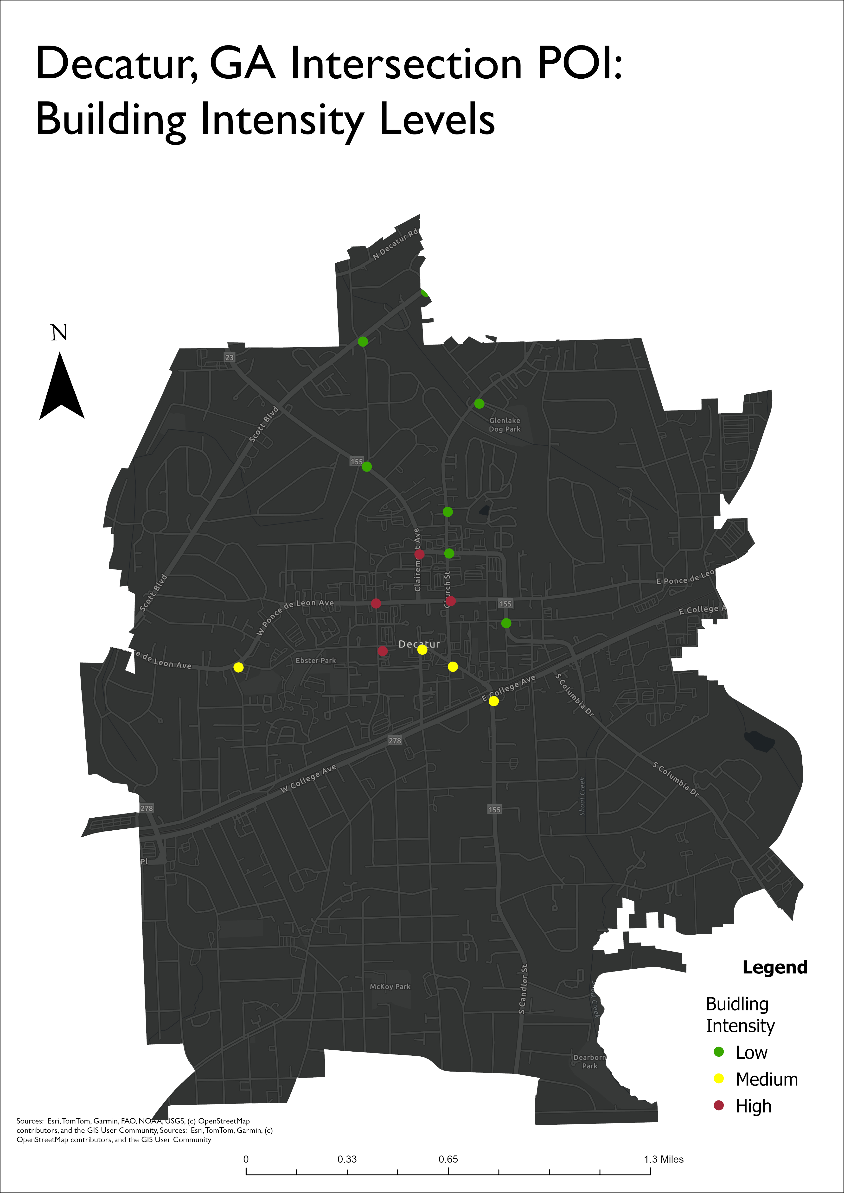

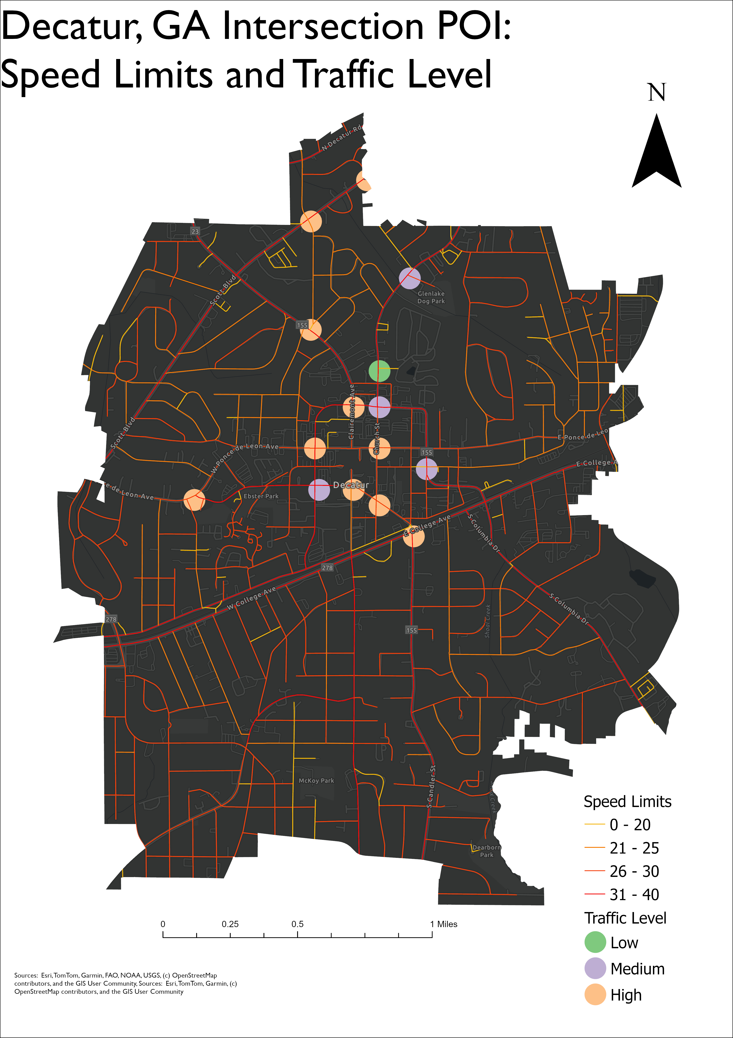

The city boasts a variety of traffic speeds via numerous routes. We made a map to represent the street speed limits within the scope of our intersection POI locations. We found that many of the higher traffic volume intersections did have higher speeds. It is important to note these are based on posted speed limits, not the speed people may actually drive. For example, most northern intersections were observed to have higher speeds than the posted speed limits. This can be further explained in the design of the road.

Overall, the traffic we observed in Decatur has some patterns in the building density and central location linked to volume. We also observed that the traffic volume can increase due to turning lane clogs or road closures. Decatur can be generally said to be a car centric community, as seen by our data and observations.

1. **Pedestrian and Cyclist Analysis**

Overall, pedestrian and cyclist activity varied highly across Decatur, with most pedestrian activity concentrated near the city center and cyclist activity being generally low and dispersed across our points of interest. We paid particular attention to intersections for data collection because pedestrian use is funneled to crosswalks, and the quality of crosswalks and perceived safety of intersections impacts the walkability of an area. We define pedestrian activity as being the number of pedestrians at any given point or intersection. Specifically, *low* pedestrian activity is 10 or less pedestrians. *Medium* pedestrian activity is 10-25 pedestrians and *high* pedestrian activity is 25 or greater pedestrians. For cyclists, we describe levels of bike activity as being the number of bicycles or cyclists at any given point or intersection. *Low* bike activity corresponds to 3 or less bicycles/cyclists. *Medium* bike activity is 3-10 bicycles, and *high* activity is 10 or more bicycles.

We identified the following intersections as points of interest, in addition to the specified areas where we observed notable pedestrian and cyclist use that varied from the surrounding area.

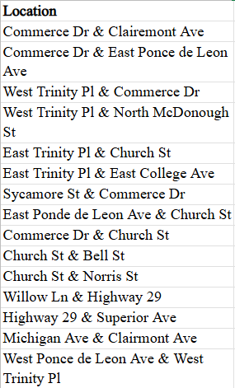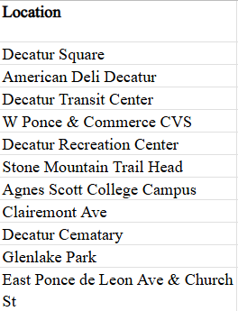

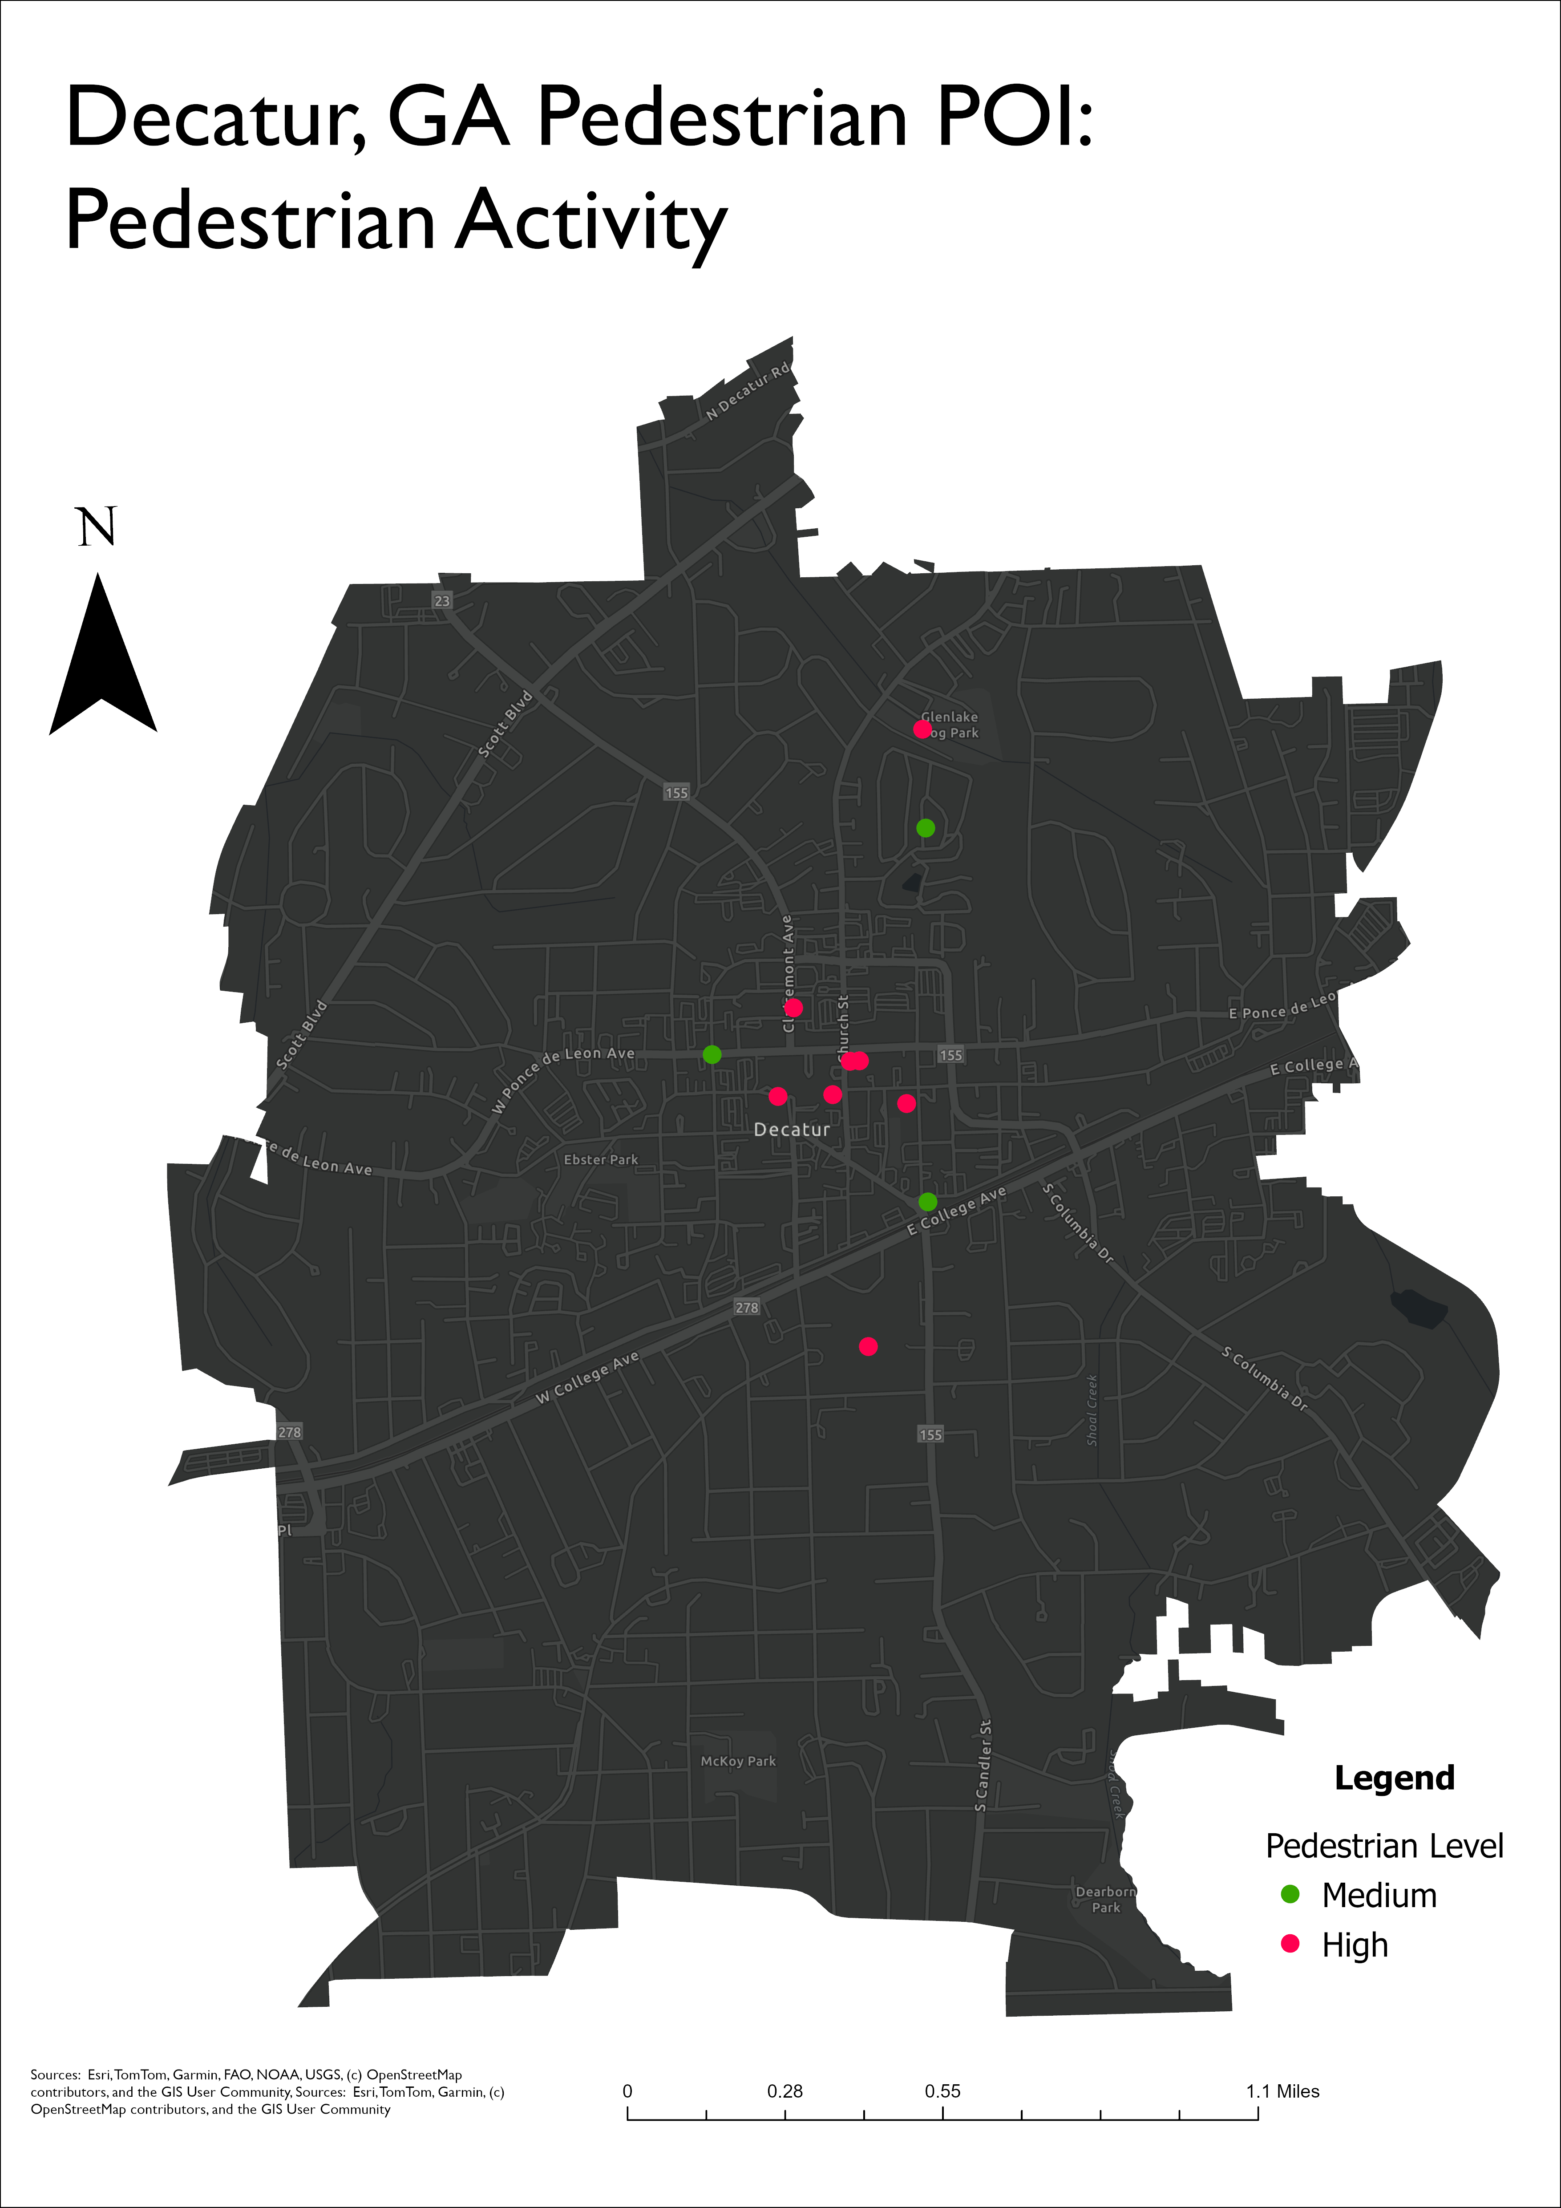

(A regional map of POIs describing the general pedestrian levels respective to the area)

In the city center, which we defined as the area contained within E Ponce de Leon Ave., Church St., E/W Trinity Pl. and Commerce Dr., we saw different levels of activity across our site visits, but the same relative trends represented. We analyzed the central area on two different occasions to gain a more accurate depiction of pedestrian use in Decatur’s central plaza. Our initial visit was on a Thursday around 6:00 p.m. and the sun set as we collected data. During this time, we saw relatively few people out, most of whom were adults. Many small businesses around Decatur Square close at 5-6:00 p.m. and although there are several restaurants, pubs and fast-food establishments, there was very little available infrastructure for people on the weeknight, families in particular. In Decatur Square and the barrier streets, we observed *medium* pedestrian activity, mostly near dining. However, during our second site visit we saw *high* pedestrian activity in the same areas. There were families with small children playing running around the plaza, a line out of the door for a coffee shop on the square, a photoshoot on the steps of the county courthouse and countless other groups of people window-shopping, walking dogs, or dining. There was also a Fall Festival that attracted many families. The contrast between our site visits was stark and yet it remained our point of interest with the highest pedestrian activity and notably, the only presence of children we observed along city streets.

The land use and urban design of Decatur’s center lend itself well to pedestrian use due to its well-marked crosswalks, maintained sidewalks, tree-lined streets, mixed-use zoning and availability of commercial amenities for all demographics. It appears that the city center is a well-utilized pedestrian hub that is continuing to improve accessibility as it is currently constructing a Hillside Play Area in the Decatur Square.

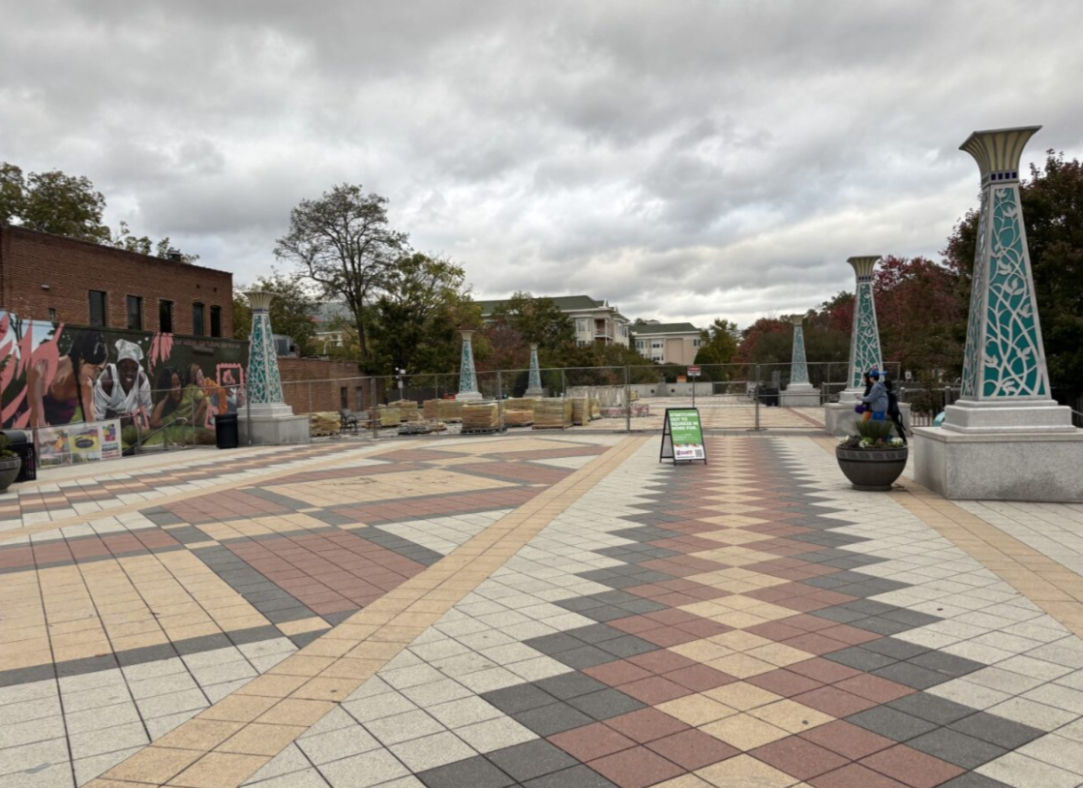

(Site visit #1: Decatur Square with two pedestrians at 6:07 p.m., during peak dining hours)

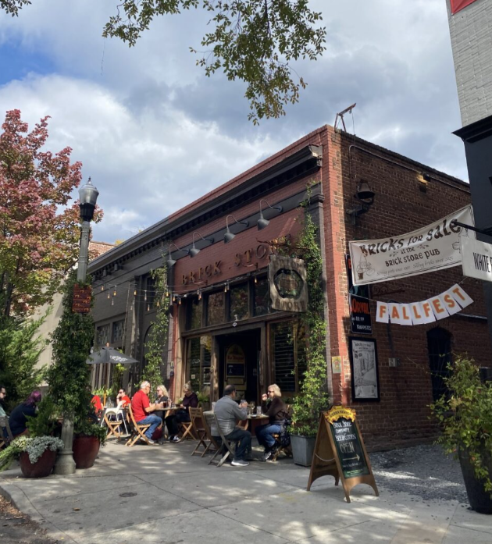

(Site visit #2: Brick Store, a restaurant along Decatur Square, packed with diners. Signage for the Fall Festival where we observed many families is visible.)

For cyclists, however, the bike level was overall *low* in the city center. Despite well-marked bicycle lanes that are separated from traffic, cyclists do not use the existing bicycle infrastructure near the city center. This was consistent across both of our site visits.

Outside of the immediate commercial center, we observed *low* pedestrian activity at all of the intersections apart from Sycamore St. And Commerce Dr., where we observed *medium* pedestrian activity. This POI is located on a block with the Decatur Library and Recreation Center where public facilities and the designated municipal land use correspond to the pedestrian presence here. Despite collecting data in residential areas, mixed-use development and commercial centers, we saw very few pedestrians out, most of whom were walking dogs or exercising. In this case, it is notable that these pedestrians do not have a destination and are not attempting to access amenities or commute. We can conclude from our analysis that Decatur is not pedestrian-friendly, and most people who do walk do so out of necessity (exercise).

Similarly, bike levels were *low* at all of our POIs, with the exception of the intersection at E. College Ave. and E. Trinity Pl. where it was *medium* activity. This outlier to cyclist activity is explained by the fact that this intersection connects Agnes Scott College to Decatur’s downtown, and all cyclist traffic is funneled through this intersection. Despite this intersection being a major byway for bicycles and despite the diverse land use that surrounds this intersection (educational, commercial and mixed-use development) in different directions, there are not many cyclists. We can make an inference – as elaborated in Section IV: Street Design – that the street design and its implications on mobility explain the low cyclist traffic here.

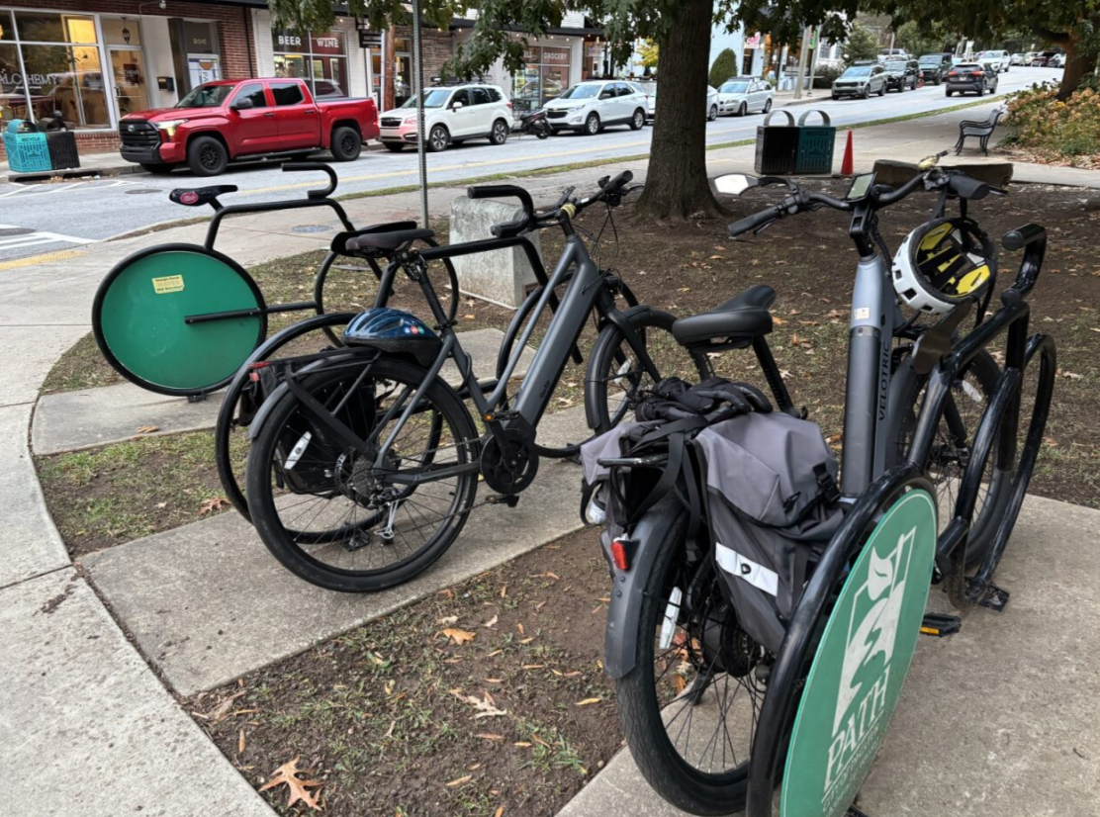

(Two bicycles parked near the intersection of E. Trinity Pl. And E. College Ave.)

On the whole, we did not see many cyclists out during either of our site visits. Notably, the few we saw rarely used the designated bike lanes, and were either on the road, or cycling on the opposite side of the street against the flow of traffic in the opposite bike lane. Although Decatur has made a visible effort to cultivate a bikeable community, its residents are not utilizing this infrastructure.

1. **Street Design**

Decatur has multiple major roads radiating from Downtown Decatur. These roads connect different neighborhoods of the city together and link Decatur to other population centers in the Atlanta area. Clairemont Ave. runs north and links the city to North Decatur, Emory University, and North Druid Hills. College Ave. and Howard St. take traffic from Downtown Decatur to Downtown Atlanta to the west and Avondale Estates and Interstate 285 to the east. Candler Rd. runs south from Downtown Decatur to East Lake and Plantersville. Finally, Ponce de Leon Ave. connects Decatur to Atlanta’s eastern intown neighborhoods and Midtown Atlanta, and to the east it runs to Scottdale, Interstate 285, and Clarkston.

Due to the street grid and pedestrianization of Decatur Square, there are no direct north-south roads that run through Downtown Decatur and limited east-west connections. This means that drivers often take Commerce Drive and Trinity Place to go around Downtown Decatur, and we found that during rush hour at 5:45 p.m. on a Thursday, intersections featuring these roads were the most congested. Of all the intersections we observed, Commerce Dr. and Clairemont Ave. was the most congested, with high levels of cars turning left from eastbound Commerce Dr. onto northbound Clairemont Ave., as well as cars turning left from southbound Clairemont Ave. to eastbound Commerce Dr. However, there was a road closure in the area, potentially changing traffic patterns to an extent.

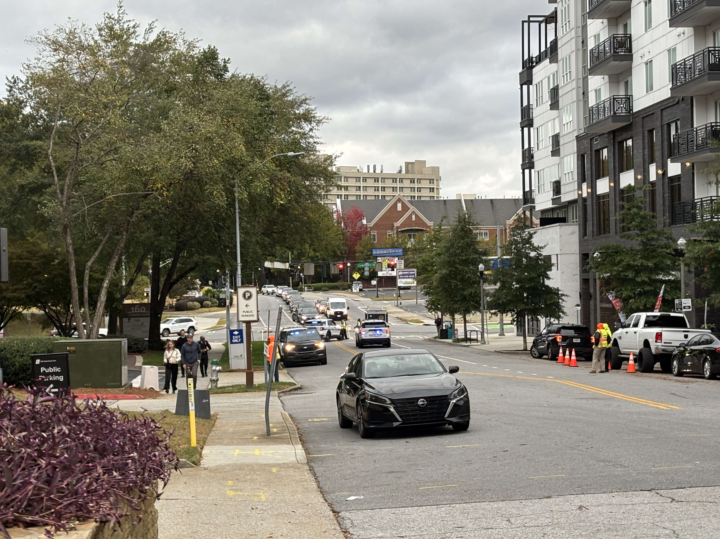

(Traffic congestion and road closure at Commerce Dr. and Clairemont Ave.)

One notable feature of some major intersections in Decatur is that they are bisected by railroad tracks. This leads to two lights that are often very close to one another, causing cars to either block intersections or not be able to turn, increasing congestion and causing safety issues. At the intersection of College Ave. and E. Trinity Pl. we observed that cars were stopped on the railroad tracks waiting for the light to change, and we observed multiple cars running a red left turn arrow. We did not see many pedestrians crossing at this intersection, despite apartments and businesses being located on the north side of the intersection, and Agnes Scott College and more businesses being located on the south side.

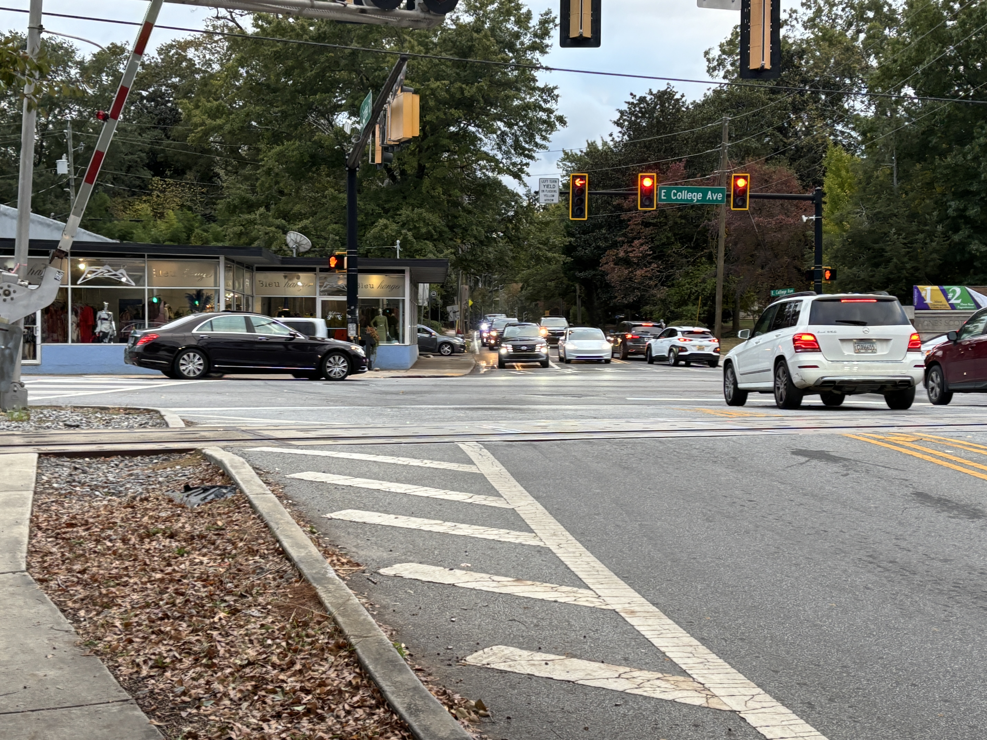

(Intersection of E. Trinity Pl. And College Ave., with cars stopped in the middle of the intersection and on the railroad tracks)

In Downtown Decatur, there are aspects of road design that improve safety and accessibility for pedestrians. E. Trinity Pl. features multiple mid-block marked crosswalks, and most intersections have marked crosswalks on all four sides. However, these mid-block crosswalks were not signalized, and some cars failed to yield to pedestrians. The intersection of Clairemont Ave. and Ponce de Leon Ave. features a signalized raised crosswalk that felt like one of the safest intersections to cross as a pedestrian, due to slow vehicle speeds and limited lanes for cars traveling through the intersection.

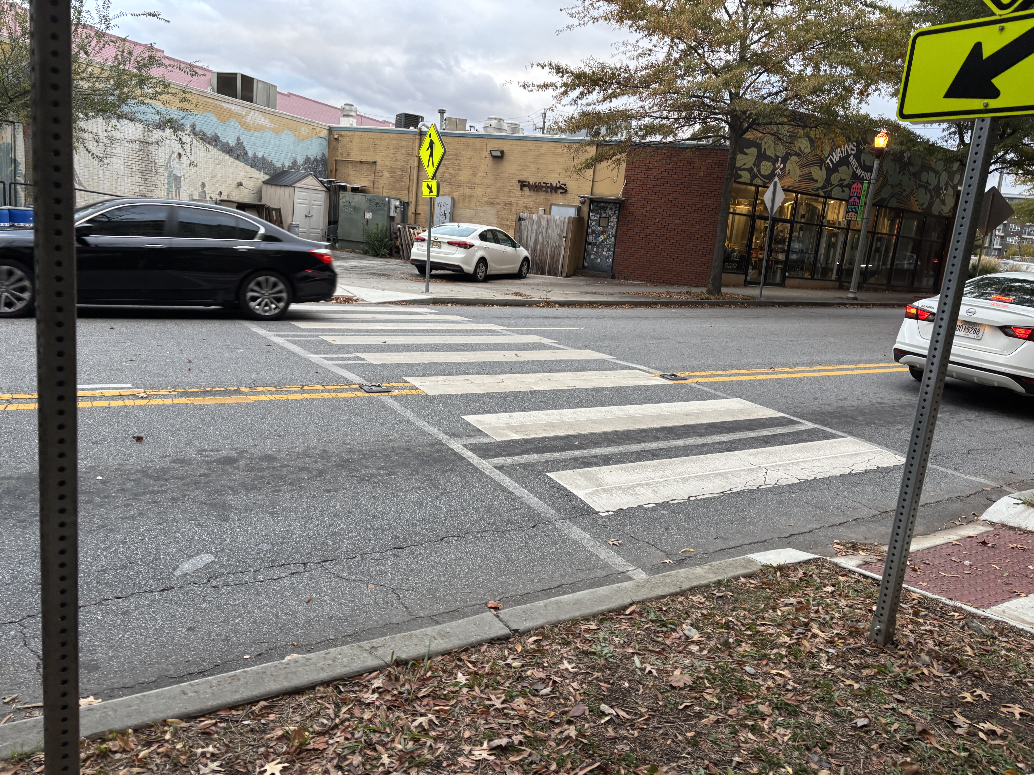

(Mid-block crosswalk on E. Trinity Pl.)

1. **Conclusion**

From our site visits, we can conclude that Decatur is a city with high pedestrian and vehicle activity with low to moderate cyclist activity. However, pedestrian activity is most concentrated in the center of the city near the densest development, whereas vehicle activity is relatively high throughout the city, with particular intersections being more congested than others due to location, design, or capacity limitations. We can see that there is a difference in the correlation between the different variables we measured. With our observations, we found that the strongest positive correlation was between Traffic Level and Building Intensity, whereas the weakest negative correlation was between Bike Level and Pedestrian Activity. From our data collection, we can see the foundations of possible statistical significance between selected variables. To complete more precise research, more samples, data interpretation, and time can provide better results. In summary, through our research on Decatur’s land use we have found the city to be filled with car activity and pedestrian activity, specifically downtown. There is also evidence that certain land uses, such as high-density buildings, increase both vehicle and pedestrian volume.

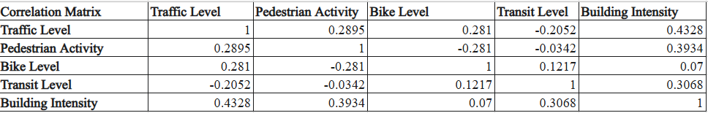

**Citations**

Open Data Portal City of Decatur, GA. data-decaturga.opendata.arcgis.com.

**Appendix**

[**Data Deliverable 2.xlsx**](https://gtvault-my.sharepoint.com/personal/tpharr3_gatech_edu/_layouts/15/Doc.aspx?sourcedoc=%7B2BE4E61D-BFEE-4BAD-9E95-D08374A427B4%7D&file=Data%20Deliverable%202.xlsx&action=default&mobileredirect=true)

[Intersection_Building_Intensity.jpg](https://gtvault-my.sharepoint.com/:i:/g/personal/tpharr3_gatech_edu/EcPqcAhXAl5GtGNwRzKAQmAB53HXwJj7qi25Q3qT4PAaVw?e=eEXMtX)

[Intersection_Pedestrian.jpg](https://gtvault-my.sharepoint.com/:i:/g/personal/tpharr3_gatech_edu/EVBphTL02O1EumrS_quqIiYBEOa79EDKSQgzRkrqmO8W_g?e=TjCm4Y)

[Intersection_Traffic.jpg](https://gtvault-my.sharepoint.com/:i:/g/personal/tpharr3_gatech_edu/EUEmSPmAV2xJkGRVpghWL_8Bv30c6t4YjI21bjpHfe5sUw?e=BOX4BY)

[Intersection_Transit.jpg](https://gtvault-my.sharepoint.com/:i:/g/personal/tpharr3_gatech_edu/Efw4u6zluWFIjUka9TpqE_ABSdqsWvM4B0vXY3SMRE2Sbw?e=vKMwve)

[Ped_POI.jpg](https://gtvault-my.sharepoint.com/:i:/g/personal/tpharr3_gatech_edu/EbnyJ_k_4dFLtCx4A8UhSTEBGSmhAsPo70pJWw81bspvjA?e=IcDBDh)

[Traffic Level and Speed Limits.jpg](https://gtvault-my.sharepoint.com/:i:/g/personal/tpharr3_gatech_edu/EdG6Ln644WZFhHcxvY0TN-IBvp3sOdhcFS6ENSIh-h1X4w?e=13LMfq)